**Tables – advanced features**

On a new document, create the following table.

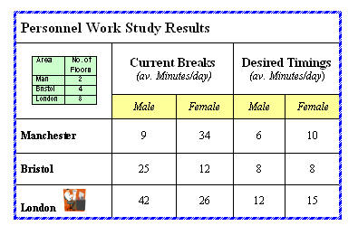

*Your table does not have to look exactly like this.*

To create this table, you will need to:

* merge cells
* erase column lines (another way of merging cells)
* insert a nested table inside the vertically merged cells above "Manchester"
* insert an in-line ClipArt picture

Save the document with the name:    **Work Study Results Table**    and then close it.